Catherine 'Kate' Middleton Biography
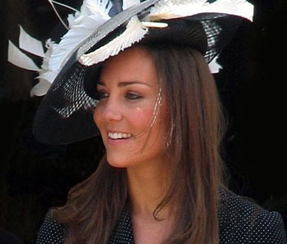
Catherine Elizabeth "Kate" Middleton (born 9 January 1982) married to Prince William of Wales, elder son of Prince Charles, and the late Diana, Princess of Wales.
After her marriage, the official title of Miss Catherine Middleton is - Her Royal Highness The Duchess of Cambridge.

Early life Kate Middleton
Born at the Royal Berkshire Hospital in Reading, Berkshire, England, Kate Middleton is the elder daughter of self-made millionaire Michael Middleton (born 1949), who was an airline officer at the time of her birth, and his wife, the former Carole Goldsmith, who was an air hostess. Her parents now own Party Pieces, a mail order company that sells children's party paraphernalia. She has a younger sister, Philippa ("Pippa") and a younger brother, James.
Kate Middleton was raised in Bucklebury, Berkshire, in the south of England. She went to St Andrew's School, Pangbourne until she was 13 and then attended the public school Marlborough College (the same school William's cousin Princess Eugenie of York attends), where she passed eleven GCSEs and three A-level exams.
In 2000 Kate Middleton took a gap year. She headed to Florence in September for an intensive 12-week course in Italian at the British Institute.
Like the Prince, Kate Middleton was a student at the University of St Andrews in Fife, Scotland. She graduated in 2005 with a 2:1 (Upper Second-Class) MA (Hons) degree in History of Art.

Kate Middleton and Prince William
While attending the University of St Andrews in 2001, Kate Middleton met Prince William of Wales. At the time, Kate Middleton was already in her second year at St Andrews. Since around Christmas of 2003 she and Prince William have been involved in a relationship that has been subjected to intense media attention.

Engagement of Kate Middleton and Prince William
On 16th November, 2010, Kate Middleton and Prince William announced their plans to marry in the new year.

Wedding of Kate Middleton and Prince William
Kate Middleton and Prince William were married on Friday 29th April 2011 at Westminster Abbey, London.
On the morning of the wedding, the Queen gave a new title to her grandson, Prince William - The Duke of Cambridge.
The official title for Miss Catherine Middleton on her marriage is Her Royal Highness The Duchess of Cambridge.
After the wedding, the couple intend to continue residing on the Isle of Anglesey in North Wales, where Prince William is based as an RAF Search and Rescue pilot.
In late 2012, the Duchess of Cambridge announced she was expecting the couples first baby

