Fingerprinting
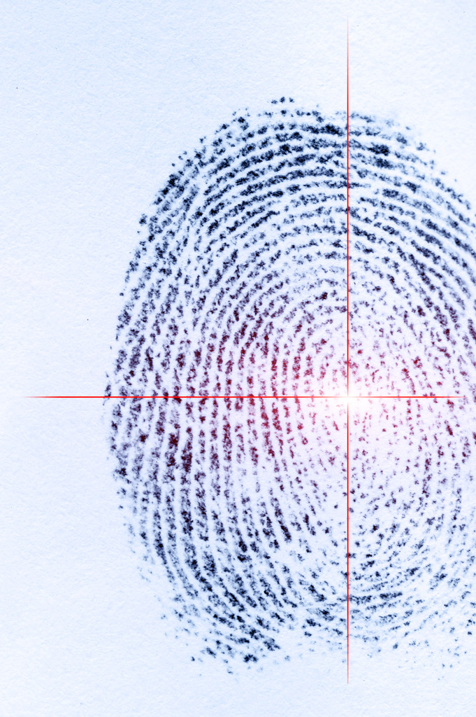
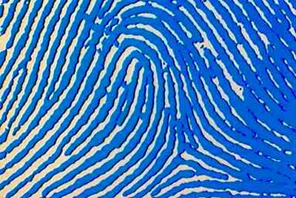
Label: LT
Pattern: loop

Dactyloscopy is the practice of using fingerprints to identify someone. For just over 100 years, police forces within the United Kingdom have been using fingerprinting for identification and it still is a powerful tool in the fight against crime.
- The patterns of ridges on our finger pads are unique: no two individuals, not even identical twins have fingerprints that are exactly alike.
- We leave impressions or prints of these patterns on everything we touch with any pressure.
- The prints can be visible as when our fingers are dirty or oily, or they can be latent, as when they are made only by the sweat that is always present on our finger ridges.
- Injuries such as burns or scrapes will not change the ridge structure: when new skin grows in, the same pattern will come back.

Extension:
Which is the most common pattern in the class?
Can you work out what the % for the most common pattern is?

More interesting finger facts!
- The most common fingerprint pattern is the "Loop. If you look at your own hands, the chances are you have at least one fingerprint of that type. Over 60% of all fingerprints are loops.
- Before fingerprinting, arrestees were identified by sets of eleven body measurements. These measurements were reduced to a formula which, theoretically, would apply only to one person and would not change during his/her adult life. This idea was widely used until 1903, when a man named Will West was sentenced to the U.S. Penitentiary at Leavenworth, Kansas. It was discovered that there was already a prisoner at the penitentiary at the time, whose Bertillon measurements were nearly the same, and his name was William West. Upon investigation, there were indeed two men who looked exactly alike. Their names were Will and William West respectively. Their body measurements were close enough to identify them as the same person. However, a fingerprint comparison quickly and correctly identified them as two different people.

