La Tomatina
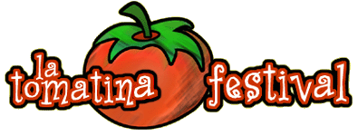

La Tomatina es una fiesta de tomates que se celebra en el verano en la región de Valencia. La fiesta tiene lugar en un pueblo valenciano que se llama Buñol y se celebra siempre el último miércoles de agosto. La fiesta se llama la Tomatina porque se trata de tirar tomates. Durante la fiesta la gente arroja cuarenta kilos de tomates (apróximadamente 150,000 tomates) durante una hora. La fiesta empezó en el año 1959. Hoy en día la Tomatina es muy popular y hay entre 20,000 y 30,000 visitantes a la región valenciana para la fiesta.

1 | La Tomatina takes place
 |  | in winter. |  |  | in summer. |  |  | in spring.
2 | The village where the festival takes place is called
 |  | Valencia. |  |  | Valenciano. |  |  | Buñol.
3 | The festival always happens on the
 |  | first Wednesday of August. |  |  | last Wednesday of August. |  |  | last Tuesday of August.
4 | 1959 was the year
 |  | the festival began. |  |  | the festival ended. |  |  | there was no festival.
5 | In total people throw around
 |  | 40 kilos of tomatoes |  |  | 40,000 tomatoes |  |  | 150 kilos of tomatoes
6 | Each year the festival attracts
 |  | 50,000 visitors. |  |  | 20,000 - 30,000 visitors |  |  | 10,000 visitors.

