Pablo Picasso was a master of abstract art. Abstract art is artwork that doesn't seem to show objects the way they normally are, but instead looks for a different way of representing them.
Now you can learn this technique too, and what's more, in three dimensions!
You will need:
- Teabag box, or other boxes
- Tape
- Scissors
- PVA glue
- Kitchen roll
- Acrylic paint
- Black pen

 | 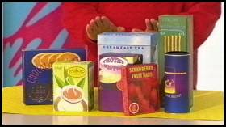 |  | To begin with, you need to find a box like a teabag box, or biscuit box. The ones in this picture are some examples of the kind that work well for this Art Attack.

 | 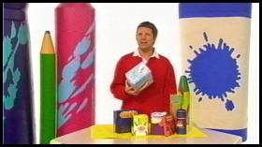 |  | Start thinking... but think abstract!  Well, this is a boring, ordinary rectangular box right now. So start by breaking up its shape.

 | 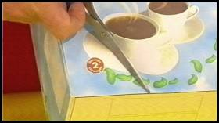 |  | You can do this any way you like, but Neil started on one side of his, about half way up.  Cut a diagonal to the bottom.

 | 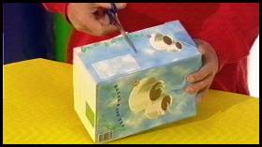 |  | Do the same on the other side but this time continue around the side...

 | 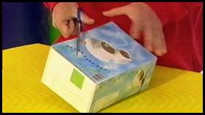 |  | ... and down the back, again on the diagonal.

 | 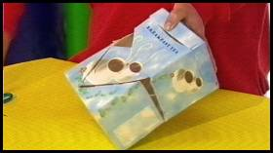 |  | On the first diagonal just cut out a triangular eyehole.

 | 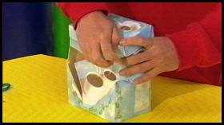 |  | Then lift the lid and just crush the top corner a bit to alter the shape of the box. This doesn't have to be perfect.  The idea is to just alter the shape!

 | 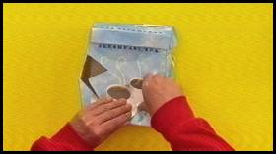 |  | When you've done that, tape it all into place.  This will be the basic head shape.

 | 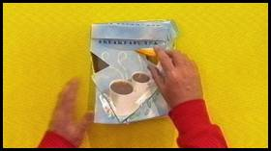 |  | Next you need to add some features.  Do this using the corners of the other boxes you collected. Here's one for an eye.

 | 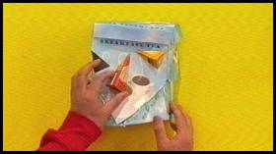 |  | One for a nose, slightly off centre.

 | 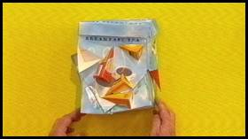 |  | And another eye in a different place.  You could even do it upside down like Neil you can see here. Just keep experimenting and eventually your abstract face will start to appear. When you're happy with your arrangement, tape everything securely down.

 | 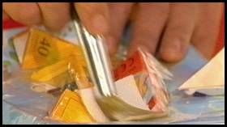 |  | Go over everything with some PVA glue mixed half and half with water, adding on a layer of kitchen roll.  Make sure you get into all of those nooks and crannies, sealing over all the joins.

 | 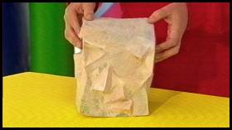 |  | When you've covered over all of theface and it has dried, you'll have something that looks like this.

 | 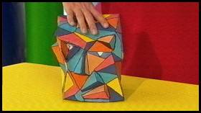 |  | Now you can paint it in an abstract way!  Acrylic paint works really well for this. As you can see here, this one has angular shapes painted all over the face, and every shape is a different colour.  Don't forget the eyes, and you can even use a black permanent pen to pick out all the details. This is called a "cubist" style.

 | 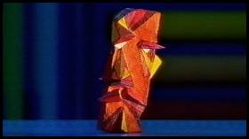 |  | If you really want to go crazy, you can even make your own abstract art gallery!

 | 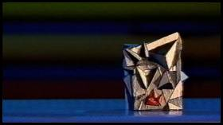 |  | Try it yourself!

