Year 6 French Quiz 2B: Read aloud

Read aloud the following French words for animals. You have not learnt these words so apply what you know about how to pronounce French.
1 | la puce | 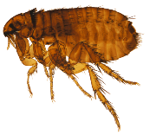 |  | 6 | l’oie | 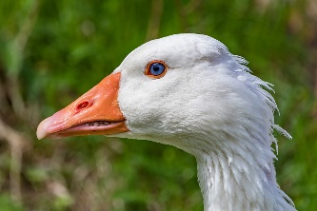
2 | la loutre | 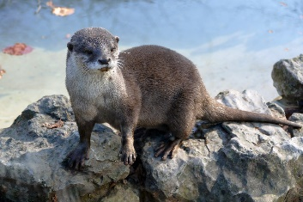 |  | 7 | la vache | 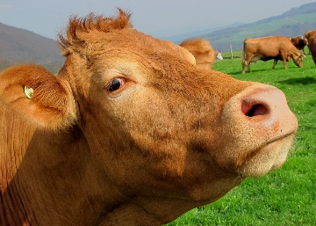
3 | le triton | 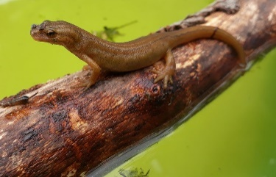 |  | 8 | la baleine | 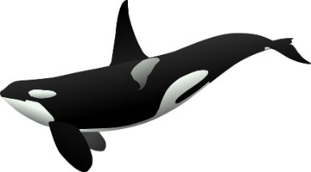
4 | la dinde | 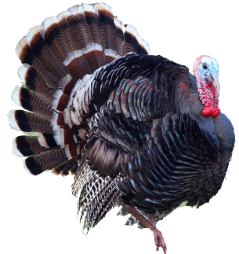 |  | 9 | le faisan | 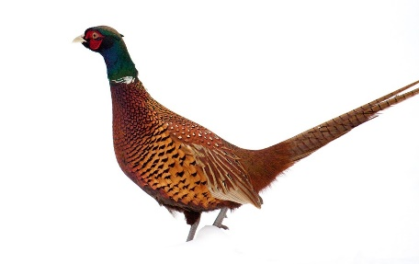
5 | le veau | 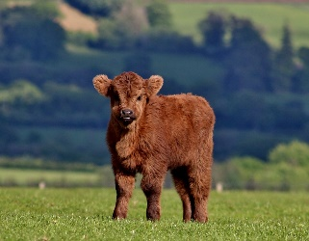 |  | 10 | le serpent | 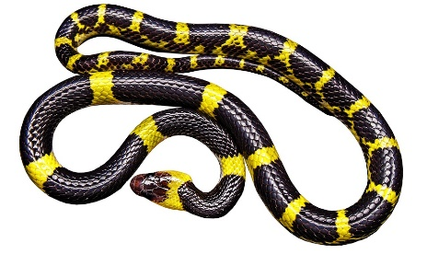

11 | le sanglier | 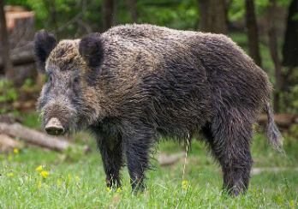 |  | 16 | les rongeurs | 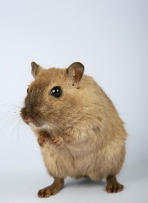
12 | l’étoile de mer |  |  | 17 | le requin | 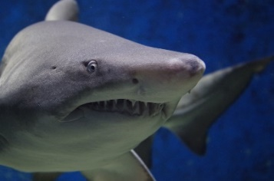
13 | le furet | 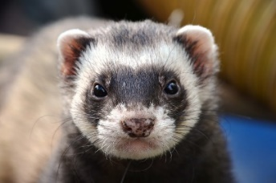 |  | 18 | le renard | 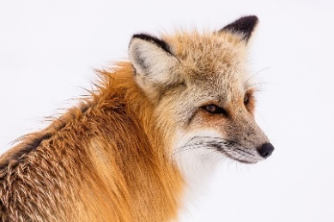
14 | les colibris | 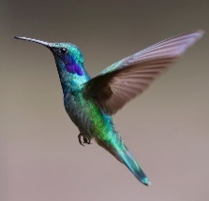 |  | 19 | le thon | 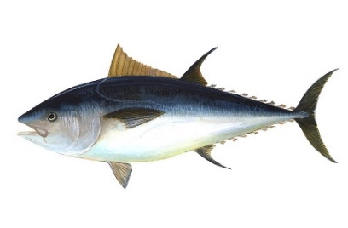
15 | le têtard |  |  | 20 | le rossignol | 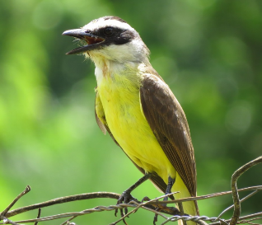

Year 6 French Quiz 2B: Read aloud – diagnostic scoring sheet
Pupil name: _________________________
 |  |  | / x
la puce | 1 | u
la loutre | 2 | ou
le triton | 3 | on
la dinde | 4 | in
le veau | 5 | o/eau/au
l’oie | 6 | oi
la vache | 7 | ch
la baleine | 8 | ei
le faisan | 9 | ai
le serpent | 10 | en
le sanglier | 11 | an
 | 12 | er
l’étoile de mer | 13 | é
le furet | 14 | r
 | 15 | SFC-t
les colibris | 16 | i
 | 17 | SFC-s
le têtard | 18 | SFC-d
les rongeurs | 19 | eur
le requin | 20 | qu
le thon | 21 | th
le rossignol | 22 | gn

Year 6 French Quiz 2B: Read aloud – diagnostic scoring sheet
Pupil name: _________________________
 |  |  | / x
la puce | 1 | u
la loutre | 2 | ou
le triton | 3 | on
la dinde | 4 | in
le veau | 5 | o/eau/au
l’oie | 6 | oi
la vache | 7 | ch
la baleine | 8 | ei
le faisan | 9 | ai
le serpent | 10 | en
le sanglier | 11 | an
 | 12 | er
l’étoile de mer | 13 | é
le furet | 14 | r
 | 15 | SFC-t
les colibris | 16 | i
 | 17 | SFC-s
le têtard | 18 | SFC-d
les rongeurs | 19 | eur
le requin | 20 | qu
le thon | 21 | th
le rossignol | 22 | gn

