Year 6 French Quiz 1B: Read aloud

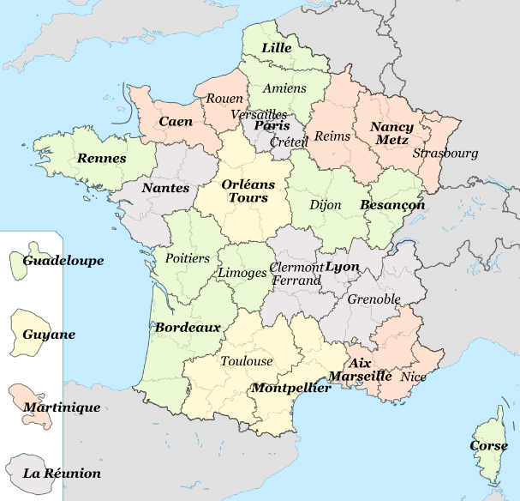
Read aloud the following French place names. You have not learnt these words so apply what you know about how to pronounce French.
1 | Cluny |  | 8 | Liévin
2 | Coucy |  | 9 | Talence
3 | Foix |  | 10 | Melun
4 | Pau |  | 11 | Nantes
5 | Meaux |  | 12 | Falaise
6 | Dreux |  | 13 | Niort
7 | Chinon

Enseignement_en_France_1.PNG: BabsyRégions_de_France.svg: Solsticedhiverderivative work: Ash_Crow [CC BY-SA 3.0 (https://creativecommons.org/licenses/by-sa/3.0)]

Year 6 French Quiz 1B: Read aloud

Read aloud the following French place names. You have not learnt these words so apply what you know about how to pronounce French.
1 | Cluny |  | 8 | Liévin
2 | Coucy |  | 9 | Talence
3 | Foix |  | 10 | Melun
4 | Pau |  | 11 | Nantes
5 | Meaux |  | 12 | Falaise
6 | Dreux |  | 13 | Niort
7 | Chinon

Enseignement_en_France_1.PNG: BabsyRégions_de_France.svg: Solsticedhiverderivative work: Ash_Crow [CC BY-SA 3.0 (https://creativecommons.org/licenses/by-sa/3.0)]
Year 6 French Quiz 1B: Read aloud – diagnostic scoring sheet / 20
Pupil name: _________________________
 |  |  | / x
Cluny | 1 | u
Coucy | 2 | ou
Foix | 3 | oi
 | 4 | SFC-x
Pau | 5 | au
Meaux | 6 | eau(x)
Dreux | 7 | eu
 | 8 | SFC-x
Chinon | 9 | ch
 | 10 | on
Liévin | 11 | é
 | 12 | in
Talence | 13 | en
Melun | 14 | e (uh)
 | 15 | un
Nantes | 16 | an
 | 17 | SFC-s
Falaise | 18 | ai
Niort | 19 | i
 | 20 | SFC-t

Year 6 French Quiz 1B: Read aloud – diagnostic scoring sheet /20
Pupil name: _________________________
 |  |  | / x
Cluny | 1 | u
Coucy | 2 | ou
Foix | 3 | oi
 | 4 | SFC-x
Pau | 5 | au
Meaux | 6 | eau(x)
Dreux | 7 | eu
 | 8 | SFC-x
Chinon | 9 | ch
 | 10 | on
Liévin | 11 | é
 | 12 | in
Talence | 13 | en
Melun | 14 | e (uh)
 | 15 | un
Nantes | 16 | an
 | 17 | SFC-s
Falaise | 18 | ai
Niort | 19 | i
 | 20 | SFC-t

