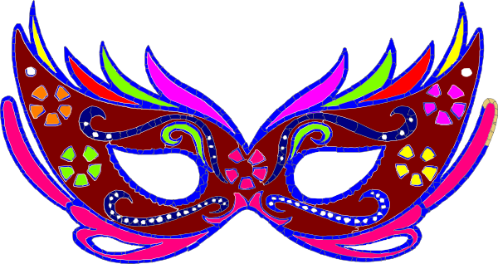Le carnaval

La période de carnaval commence le 6 janvier (la Fête des Rois) et se termine le Mardi Gras. Mardi Gras est le dernier jour du carnaval.

Il y a des carnavals partout dans la France, les plus célèbres sont à Nice et à Dunkerque.

Ces fêtes sont l’occasion de se déguiser, de chanter, de danser et surtout de s’amuser.

1 | Le Carnaval takes place
 |  | in winter. |  |  | in summer. |  |  | in spring.
2 | The town where the festival takes place is called
 |  | Avignon . |  |  | Nice. |  |  | Dunkerque.
3 | The festival always starts on the
 |  | 6th January |  |  | 6th February |  |  | 6th December.
4 | At the festival the people
 |  | wear special costumes. |  |  | throw pancakes. |  |  | decorate their houses.
5 | The day the carnaval starts is called
 |  | La fête des mères |  |  | La fête des rois |  |  | La fête des pères
6 | At the carnaval people
 |  | eat hotdogs. |  |  | sing and dance |  |  | give up sweets

