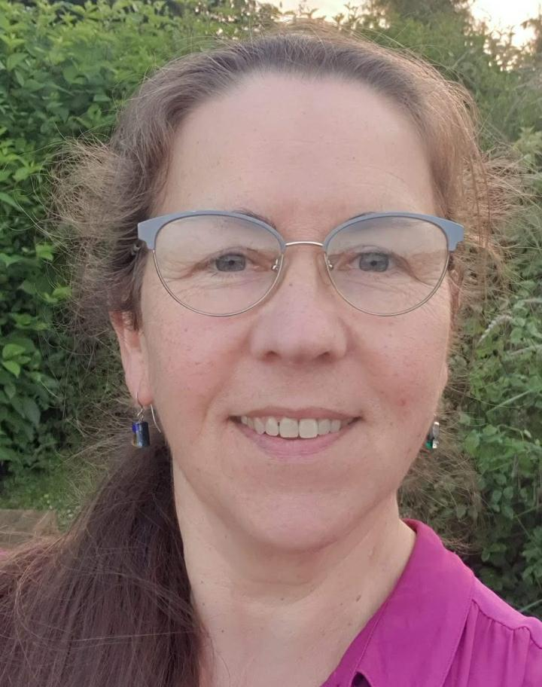
Marie-Odile Guillou comes from a beautiful small village by the seaside in North Finistère, France. Her first degree was in combined physics and chemistry from the university of Rennes. She has always loved languages and hence she pursued her studies in Oxford (`CLIL´ teaching in Physical Sciences). Then, she obtained a PhD in Engineering from the University of Exeter. She published over 35 scientific papers whilst working as a University postdoctoral researcher. She enjoyed teaching technical French and English to Erasmus undergraduate Engineering students. She taught French up to GCSE level in a private school but decided to teach in the primary schools´ sector when languages became compulsory from KS2 in September 2014 in order to give pupils a solid start in their language learning journey. She was awarded a certificate of participation in both the KS2 and KS3 ALL Connect teacher CPD programmes taught by Dr. Rachel Hawkes and Ms. Jane Driver before starting teaching French across a number of State primary schools near Cambridge. She has also been running KS1 and KS2 French lunch-time clubs in Primary Schools since January 2015. Marie-Odile enjoys sharing her French expertise freely in the LIPS (Languages in Primary Schools) Facebook group. She is a private French tutor (any age and any stage). In her spare time, she enjoys photography, organic gardening, singing in a Cambridge-based community choir and playing Scrabble! She is now semi-retired, writes free French CLIL resources on her YouTube channel and is a DELF DALF corrector/examiner for levels A1.1 A1 and A2.

YouTube.com/MarieOdileGuillou

@MarieO_Guillou

gmarieodile

