Lesson | Learning objective | Skills and language taught | Activities and resources | Assessment
1 | LO: To place historical events in chronological order  To learn basic facts about Ancient Egypt | To learn and revise high numbers in French  Improve reading skills  Knowledge of Ancient Egypt in time line | Pupils place Ancient Egypt on time line.  Use and practise high numbers  Reading comprehension about Egypt  Find modern day Egypt on the map and locate key towns and seas on Ancient Egypt map (work in pairs)  http://www.childrensuniversity.manchester.ac.uk/interactives/history/egypt/egyptiantimeline.asp | To ascertain how much knowledge pupils have already.  (Geography and History)  Knowledge of numbers
2 | LO: To identify and describe the reasons for the Nile’s importance in Ancient Egypt. | Use memory strategies and cognates  Revise and practise listening strategies and skills  Using pourquoi and parce que | Presentation of key words for project  Use memory strategies and activities to learn words rapidly.  Gap fill listening about the Nile and its importance for the Egyptians.  Simple summary sentences about the Nile | Listening assessment
3 | LO: To find out about the people Egypt from artefacts that are left behind | Categorising and classification  Agreement and disagreement  Putting forward your point of view  C’est utile? Ce n’est pas utile parce que  Describing artefacts using adjectives  Using ‘je pense que’ , ‘c’est vrai ‘  je suis d’accord avec toi , mais | In groups pupils decide:  a) what objects are  b) If they are useful or decorative  c) classify them into two columns  Maybe look at a mummy and why certain artifacts are found with the mummy. What kind of person was he/she?  Individually write a summary of 3 of their favourite objects. | Use of target language by pupils.
4 and 5 | LO: To understand the experiences of people in Ancient Egypt. | Group work and collating information.  Identification of jobs from paintings and statues and brief information given to them.  Presenting to others and communicating key information in French to peers.  Use of reflexives:  Je me lève à  Je me couche à  Other 1st person verbs in present tense:  j’utiilise, je vais, je travaille, j’aime, jen’aime pas..  Question words:  Qu’est-ce que tu fais chaque jour?  Tu aimes ton travail?  Oú travailles–tu?  Tu travailles combien d’heures?  Qu’est-ce- que tu fais d’abord? Ensuite? | Each group given some clues and facts about an Ancient Egyptian. Short paragraph about the job. Pupils use dictionaries and write bullet points to work out what the job is. Pupils nominate one person to stay on the table to be the expert and the others are envoys to other tables with fact sheet. Each go to a new table to learn info about the other jobs.  Pupils then return and tell their table about what they have learnt.  Pupil s chose a job and complete a:  ‘Day in the life of…’ as a Poster, a mind map or written account.  Interview each other about the job – 5 easy questions. Pupils could film each other and show to class: | Reading skills and use of target language by pupils  Written assessment  Speaking assessment
6 | LO: To select and organise historical information  Revise pronunciation patterns and how to work out sounds for new words | Working with and using past tense  Reading skills  Logical deduction skills  Practise pronunciation skills | Pair work:  Simple text about discovery of Tutankhamun’s tomb. Pupils have to re-arrange sentences in correct order and work out meaning.  Revise pronunciation patterns with class.  Read out to each other – points for pronunciation skills. | Peer assessment of pronunciation skills.
7 and 8 | LO: To write using different registers – a factual piece for a newspaper | Using key past tense verbs in first person.  Adjectives and exclamatory remarks.  Time expressions | Pupils write own account of the discovery of the tomb for a newspaper article.  Can include pictures.  Could be done on ICT site to create own newspaper. Website?  Also on Storybird website  http://storybird.com/ | Writing Assessment  Use of past tense extended sentences, time expressions.  Writing in different registers..
9 | LO: To write using different registers – instructions on how to build a pyramid. | Use ‘il faut’ ‘on doit’ + infinitive  Use time expressions:  d’abord, ensuite, après  C’est une bonne idée  Voila! | Group work:  Pupils work out how to build a pyramid.  Draw a poster or list illustrated list of instructions for display.  Hints in French given. | Work to be displayed
10 | LO: To use advanced reading skills and oral skills. The death of King Tutankahamun: illness or murder? | Debate language  je pense que  à mon avis  je crois que  non, je ne suis pas d’accord  To recognize and use simple imperfect key verbs:  il était, il avait, il n’était pas, il n’avait pas | Pupils given fact sheet with clues about the death of King Tutankhamun.  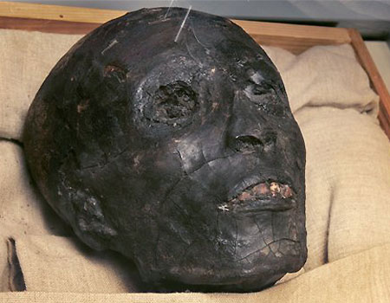  They must decide in groups if he was killed or died of an illness.  Understanding of text using cognates and visual clues.  Debate in groups – spokesman from each group. Preparation for debate involves all in group (give roles) | Using target language for a purpose.
11 and 12 | LO: To understand codes and symbols in Ancient Egyptian society | Pour – in order to  symbolise  contre  le dieu  le pouvoir  la mort  le soleil  la vie  la bonne santé  De nos jours / aujourd’hui..par contre  on porte, on croit que  porte-bonheur | Pyramid of power – who were the most powerful people in Ancient Egypt.  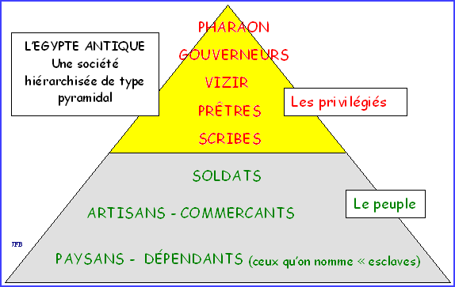  Pupils guess the symbolic meaning of animals and objects for the Ancient Egyptians.  Pupils create their own symbols for power or mummification and reasons why.  Pupils compare with modern day symbols in our society and superstitions . | End of project assessment:  Get feedback from pupils about what they learnt about Egypt and if they enjoyed the project.  Write down what skill did they most improve?  Quiz / reading comprehension to assess knowledge.  Continuous assessment during project of key skills.  Would they recommend the project to other classes? Why?

