Y7 Languages
Name: ______________________________________ Tutor Group: _____
Write here any languages you speak, where, how often and with whom.
Language | Where [e.g. at home] | How often | Spoken with...
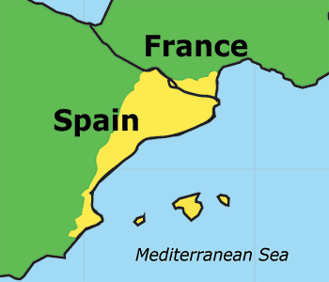
[1] This challenge involves English, French, Spanish, Catalan and Basque.
Catalan is spoken in north-eastern Spain and southern France.
It is very similar to French and Spanish.
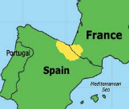
Basque is spoken in north-eastern Spain and southern France.
It is different from Spanish and French, but with some similarities.
Catalan colours in alphabetical order
blanc, blau, gris, marro, negre, porpra, rosa, taronja, verd, vermell
Here are some colour words in Catalan.
a. Look carefully at the colour words in English, French and Spanish. Write the correct Catalan colour words in the table.
English | French | Spanish | Catalan | Basque
black | noir | negro
white | blanc | blanco
grey | gris | gris
pink | rose | rosa
red | rouge | rojo
blue | bleu | azul
green | vert | verde
orange | orange | naranja
purple | violet | púrpura
brown | brun | marrón
Basque colours in alphabetical order
arrosa, beltz, berde, gorri, gris, laranja, more, marroi, urdin, zuri
Here are some Basque colours.
b. Look at the table below. It has the names of some foods in Basque, along with the colour of each food. Write the English meaning of the Basque food word in the table.
Basque food item | Basque colour | English meaning of food item
jogurt | zuri
kafe | beltz
tomate | gorri
alberjina | more
c. Now write the correct Basque colour words in the colours table in a. above.
[2] Below are French, Italian, Portuguese and Spanish translations of the same text, from the Vasa Museum brochure in Stockholm. The Vasa was a ship which sank in 1628 in Stockholm whilst on its maiden voyage (first trip). You can visit its wreck in the museum.
Look carefully at the four texts and then complete the exercises.
French | Le 10 août 1628, le Vasa a pris la mer pour son voyage inaugural et a sombré dans le port de Stockholm.
Italian | Il 10 agosto 1628 il vascello Vasa affondò nel porto di Stoccolma dopo essere salpato per il suo viaggio inaugurale.
Portuguese | A 10 de Agosto de 1628, o Vasa afundou-se no porto de Estocolmo na sua viagem inaugural.
Spanish | El Vasa se hizo a la vela en su primera travesía y se hundió en el Puerto de Estocolmo el 10 de Agosto de 1628.
a. Complete the table by writing the French, Italian, Portuguese and Spanish translations of the following words:
English | French | Italian | Portuguese | Spanish
Stockholm
port
the 10th August

b. The following phrases from the text all mean ‘maiden voyage’ (first trip).
French | Italian | Portuguese | Spanish
voyage inaugural | viaggio inaugurale | viagem inaugural | primera travesía
Which words from each language are used to mean ‘first’ and which mean ‘voyage’?
 | French | Italian | Portuguese | Spanish
first
voyage
c. Apart from ‘voyage’ are any of the words from exercise b. cognates (similar to English words)? If so, write the foreign word(s) and an example sentence in English using the word.
Foreign word(s) | English example sentence

